Indigenous Home-Lands

Housing Eco-System Overview and Strategy Development Guidance

Introduction
Indigenous groups and governments are increasingly exploring alternative and more holistic ways of addressing housing challenges within their communities. This document, along with other complementary tools, provide a series of resources that can be drawn upon and adapted by communities to identify and articulate housing ecosystems, to develop housing ecosystem strategies, and ultimately to monitor improvements in housing-related processes utilizing locally derived indicators of success.
The Indigenous Home-Lands (IHL) team at Ecotrust Canada has developed a housing ecosystem overview which takes into account the interconnected nature of housing with broader community and territorial processes and aspirations. This approach recognizes that housing, because of its link to the economic, social, and cultural well-being of a community, is one of the key leverage points for systems change and social innovation. The primary purpose of developing a housing eco-system overview is to organize pre-existing community level knowledge and information into an actionable framework that brings together previously disparate information, enabling a cross-sectoral understanding of the needs, assets, and opportunities that exist territorially such that they can be formulated into integrated housing eco-system strategies.
In developing this tool, IHL and our partners are seeking to advance Indigenous self-determination by democratizing information and processes that can serve to empower Indigenous groups and governments in relation to housing and community development. In doing so, we encourage communities to adapt and revise these documents, processes and methods in ways that work best for them. We recognize also that enacting a housing ecosystem-based approach within the context of extreme housing quality and quantity shortages can be a challenge for communities with already overstretched staffing and resources. However, we believe that it is an approach worthy of consideration, and one which can be carried out alongside and in conjunction with other practical measures aimed toward ameliorating existing housing conditions.
As an example of what a housing ecosystem overview and strategy development can look like, please refer to the latest report prepared by IHL for the Yunesit’in Government:
https://ecotrust.ca/latest/research/yunesitin-housing-ecosystem-overview-and-strategy-development-2020/

The Process: Developing a Housing Ecosystem Overview and Strategy
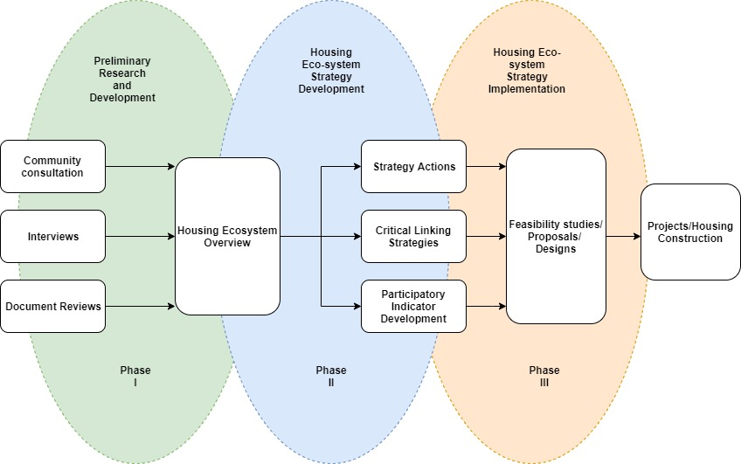

Phase I: Preliminary Research and Development
The first step in developing a housing ecosystem overview is to build the informational foundation upon which an analysis and strategy can be formulated. Methods for gathering and organizing this information can include community workshops/focus groups, interviews, questionnaires/surveys, and a comprehensive review of existing documents and reports, including for example Comprehensive Community Plans (CCPs).
Ecotrust Canada, IHL and partners have developed a series of information gathering resources that communities can adapt and utilize to fit their specific needs and contexts. These include:
- A housing ecosystem overview assessment questionnaire, to be completed by Indigenous governments or staff, which offers a snapshot in time of the housing ecosystem at the community and territorial level (Annex A)
- A household/community member survey template that can be adapted and delivered in communities
- An example housing ecosystem overview and strategy development report, delivered by IHL for partner Yunesit'in First Nation
- A housing ecosystem monitoring and evaluation framework (forthcoming)
- A ‘housing energy assessment’ survey template
No one method of information gathering can be fully relied upon in order to generate a housing ecosystem strategy. The more of the above methods and sources that can be drawn on in order to ‘triangulate’ information, the greater the reliability and validity of that piece of information. In other words, when different methods and sources of information converge on an answer and reinforce one another, the greater confidence groups can have in building a housing ecosystem strategy around that information point.
Housing – The built environment of communities, including residential, commercial and common buildings and structures, as well as the infrastructure which provide the basic and cultural needs of community members
Homelands - The natural assets within the territories of communities and the tangible and intangible goods and services that they provide
People - The members, citizens and residents of communities, and their attributes, skills, practices, knowledge and roles that facilitate individual and social well-being
Governance - the rules (or institutions) that communities put in place, or that operate informally, that determine how they organize themselves and how they interact with each other and with outsiders

Organizing Information
The housing ecosystem overview offers a way of organizing all of this information into an intuitive format that identifies and articulates the complex interactions between four categories: Housing, Homelands, People, and Governance.
Needs: the infrastructure, skills, resources and knowledge that the community needs for the achievement of their goals
Assets: the skills, resources and knowledge that exists within the community that contributes to their goals
Opportunities: the potential future assets of the community

Phase II Strategy Action Development
Once all of the information has been organized into the housing ecosystem overview categories, it can then be further assessed and organized into a framework which identifies Needs, Assets and Opportunities. This approach aims to put the strengths and assets of the community front and centre as the focal points for actionable solutions and strategies to address underlying needs.
Organizing information on housing, homelands, people and governance into the categories of needs, assets, and opportunities allows for an analysis which identifies real and potential relationships within the housing ecosystem. These can be thought of as critical linking strategies. That is, in order to create a strong housing ecosystem which satisfies diverse Needs, a community can leverage its existing Assets to develop and realize new Opportunities.
For an example of critical linking strategies, please refer to the Yunesit’in Housing Ecosystem Overview and Strategy Development report.

Needs: the infrastructure, skills, resources and knowledge that the community needs for the achievement of their goals
Assets: the skills, resources and knowledge that exists within the community that contributes to their goals
Opportunities: the potential future assets of the community

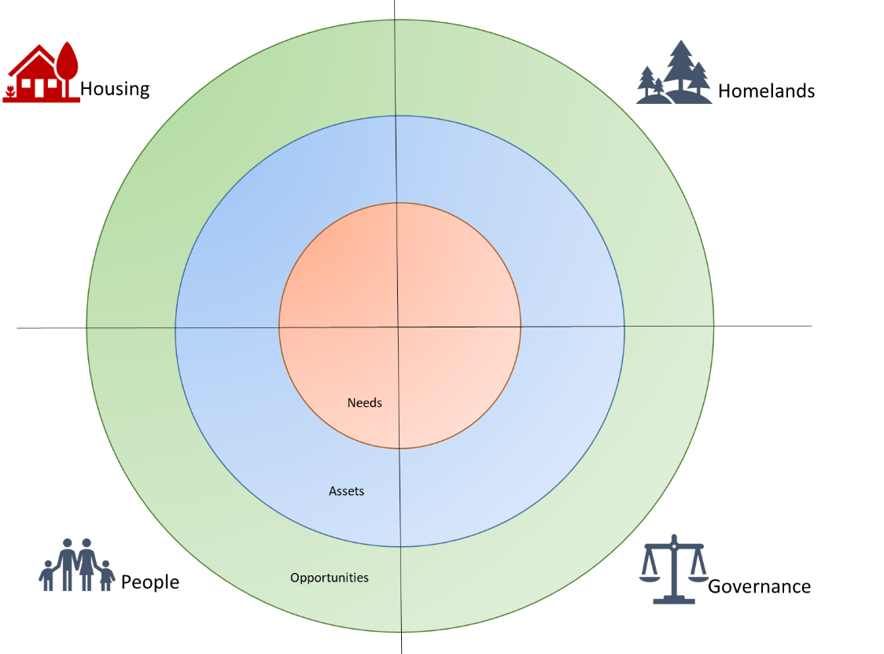

Phase III: Implementation
Implementation of housing ecosystem strategies may require the development of feasibility studies in order to ensure actions are financially achievable. However, it is important also to recognize that the implementation of a housing eco-system strategy may require initiatives and enterprises that build not only financial value, but also cultural, social and ecological value. While all efforts should be made to realize these efforts in a cost-effective manner, feasibility studies need to articulate community aspirations and values and factor them into the cost analyses of any project. Ultimately, increased costs to housing construction processes or other related enterprises may be justified within a systems approach to housing if community indicators of success are being achieved. As such, a critical process will be community engagement and participatory indicator development such that community member’s inputs, aspirations and values are actively driving the development of a housing eco-system strategy and the monitoring of its implementation.
IHL is currently working with community partners to establish a culturally-appropriate evaluative framework and methodology that highlights diverse practices of social innovation and measures, in ways that are locally meaningful, how these practices serve as pathways toward self-determination and community empowerment.
For further information and resources please see www.ecotrust.ca or contact
Anthony Persaud, Associate Director, Indigenous Home-Lands, Ecotrust Canada
anthony@ecotrust.ca

Annex A: Housing Ecosystem Overview Questionnaire
Housing
Total number of housing units on-reserve | Click here to enter text.
Total number of each building type on-reserve: | Click here to enter text.
# of single family | Click here to enter text.
# of duplexes | Click here to enter text.
# of townhouses | Click here to enter text.
# of apartments | Click here to enter text.
# of trailers | Click here to enter text.
# of Other | Click here to enter text.
Total number of each ownership structure on-reserve: | Click here to enter text.
# of Band owned (not social housing) | Click here to enter text.
# of CMHC social-housing | Click here to enter text.
# of Individual owned housing with ministerial guarantee | Click here to enter text.
# of Individual owned housing with no ministerial guarantee | Click here to enter text.
# of other housing | Click here to enter text.
Of the houses that are individually owned, do they have certificates of possession or are they band recognized? | Click here to enter text.
Which of the following housing needs are priority for the community:
Elderly | ☐ Number needed: Click here to enter text.
Students/youth | ☐ Number needed: Click here to enter text.
Single families | ☐ Number needed: Click here to enter text.
Single people | ☐ Number needed: Click here to enter text.
People with disabilities | ☐ Number needed: Click here to enter text.
Multi-Generational | ☐ Number needed: Click here to enter text.
Other | ☐ Please describe: Click here to enter text.
How many people are on the Band’s waiting list? | Click here to enter text.
Average lifespan of a house in this community | Choose an item.
Number of units in need of minor repair | Click here to enter text.
Number of units in need of major repair | Click here to enter text.
Number of units in need of replacement | Click here to enter text.
Number of units contaminated by mould | Click here to enter text.
Who pays for hydro/water | ☐ Individuals ☐ Band ☐ Combination
How is housing construction currently paid for or financed? | ☐ CMHC Subsidy ☐ ISC Subsidy  ☐ Band own-source revenue ☐ Individual mortgages  ☐ Other:
How is housing repair currently paid for or financed? | ☐ CMHC Subsidy ☐ ISC Subsidy  ☐ Band own-source revenue ☐ Individual loans  ☐ Other: Click here to enter text.
Financial institutes (banks) that currently work with the community on housing: | Click here to enter text.
Current amortization periods and interest rates on mortgages for the band/community members | Click here to enter text.
Average rental cost in the community | Choose an item.
Average rental cost in the nearest town off-reserve | Choose an item.
Current status of arrears ($) | Click here to enter text.
How are homes heated? (choose all that apply) | ☐ Baseboard Electric ☐ Wood ☐ Natural Gas  ☐ Other: Click here to enter text.
Current sources of electricity (Choose all that apply) | ☐ Hydro ☐ Solar ☐ Diesel  ☐ Other: Click here to enter text.
Current community water sources | Click here to enter text.
Current wastewater/disposal system | Click here to enter text.

Homelands
Amount harvestable timber within reserve lands available for commercial use (species, dimensions, and avg volume/hectare when harvested) | Click here to enter text.
Amount harvestable timber within reserve lands available for local/cultural use (species, dimensions, and avg volume/hectare when harvested) | Click here to enter text.
Amount of harvestable timber within traditional territory/title lands/treaty lands available for commercial use (species, dimensions, and avg volume/hectare when harvested) | Click here to enter text.
Amount of harvestable timber within traditional territory/title lands/treaty lands available for local/cultural use (species, dimensions, and avg volume/hectare when harvested) | Click here to enter text.
Community-controlled forestry tenures or co-management agreements with other operators within traditional territory | Click here to enter text.
Amount of commercially harvestable timber that the community currently has direct access to | Click here to enter text.
Other commercially harvestable resources on reserve or within traditional territory/title lands/treaty lands | Click here to enter text.
Current community-controlled natural resource-based businesses | Click here to enter text.
Natural resources currently extracted for cultural use only | Click here to enter text.
Which, if any, local resources are used in local building projects? | Click here to enter text.
Other local resources aside from timber that is/could be utilized in local housing | Click here to enter text.
Does the community own/operate a sawmill? | Click here to enter text.

People
What is the population of the Band? | Click here to enter text.
How many members live On-Reserve? | Click here to enter text.
How many members live Off-Reserve? | Click here to enter text.
Projected population in 10 years | Click here to enter text.
Average household size | Click here to enter text.
Average education level of members | Click here to enter text.
Average income of community members | Click here to enter text.
Current level of (un)employment in the community | Click here to enter text.
Number of reserves (populated/unpopulated) | Click here to enter text.
Where do most of your off-reserve members live (location)? | Click here to enter text.
Key employers on or near the reserve | Click here to enter text.
Skills and capacities that currently exist within the community in relation to housing construction: | ☐ Carpenters ☐ Plumbers ☐ Gas fitters  ☐ Electricians ☐ Sawyers ☐ Heavy equipment operators  ☐ Other: Click here to enter text.
Governance
What is the governance structure of the Nation? (choose all that apply) | ☐ Indian Act band ☐ Treaty Nation  ☐ Hereditary governance ☐ National government  ☐ Other: Click here to enter text.
Under what legal structure does the Nation make land-use and resource decisions: | ☐ First Nations Land Management Act  ☐ Indian Act  ☐ Other: Click here to enter text.
Is the Nation in the process of acquiring other lands? | Click here to enter text.
Does the Nation have an economic development corporation or similar entity? | Click here to enter text.
Does the Nation have own-source revenue and what percentage is allocated to housing? | Click here to enter text.
Does the Nation have any other agreements to provide funding to housing? | Click here to enter text.
How is housing managed by the Nation? | ☐ Band housing manager ☐ Independent housing authority  ☐ Other: Click here to enter text.
What property ownership models does the Nation utilize? | ☐ Band-owned (social)  ☐ Individually-owned (certificates of possession)  ☐ Individually-owned (band-recognized)  ☐ Individually-owned (fee-simple)  ☐ Co-operative ☐ Multi-generational owned  ☐ Other: Click here to enter text.
What property ownership models does the community wish to utilize in the future? | ☐ Band-owned (social)  ☐ Individually-owned (certificates of possession)  ☐ Individually-owned (band-recognized)  ☐ Individually-owned (fee-simple)  ☐ Co-operative ☐ Multi-generational owned  ☐ Other: Click here to enter text.

